**Project Report**

**Project Title:** Parking Management System in C++.

**Name:** Muhammad Bin Nasir

**Roll#** 243595

**Institute**: AUMC

**Section:** BSCS-B

**Supervisor:** Sir Faisal Idrees

**Subject:** Programming Fundamental

**Submission date:** January 8,2025

**Table of Contents**

**1. Introduction** 3

Overview: 3

Problem: 3

Objectives: 3

Scope: 3

Significance: 3

**2. Methodology** 3

Programming Environment: 3

Tools and Libraries: 3

System Design: 3

Flowchart: 3

Approach: 4

**3. Implementation** 4

Modules: 4

How the Code Works: 4

Features: 4

Screenshots: 4

**4. Results and Discussion** 6

Output: 6

Discussion: 6

**5. Conclusion and Future Work** 6

Conclusion: 6

Future Work: 6

**6. References** 6

# **1. Introduction**

**Overview:**  
This parking system is used to manage parking spot efficiently. This system includes login authentication, check parking status, park vehicles, remove vehicles and save parking data in text file.

**Problem:**

The main problem addressed by creating this system is easy management of parking. It is very difficult to handle parking manually. It aims to solve this problem efficiently.

## **Objectives:**

* Create a parking system in C++ to manage parking spots.
* Allow users to register, log in, and manage parking spots.
* Save and load data in text file so information isn’t lost when the system closes.

**Scope:**  
This system can manage as many spots as demanded by the user, through a simple text-based menu and saves user data and parking status in files.

**Significance:**  
This project saves time and reduces errors in parking management. It’s also a great way to learn programming concepts like file handling and basic system design in C++.

# **2. Methodology**

## **Programming Environment:**

* Dev C++

## **Tools and Libraries:**

* File handling in C++ to store and retrieve data (<fstream>)
* Basic C++ tools like arrays and functions (<iostream>)

# **System Design:**

# **Approach:**

* **Login System**: Users register or log in with a username and password stored in a file.
* **Parking Management**: The system keeps track of parking spots in an array, marking them as "Empty" or with the vehicle number.
* **Data Saving**: Parking and user data are saved in files so it is available for the next use.
* **Flowchart:** 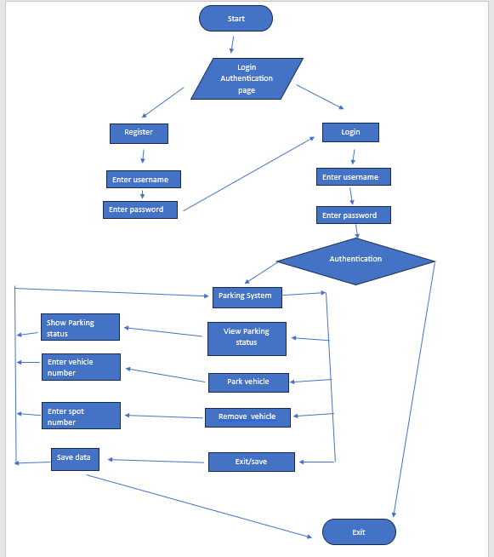****

# 

# **3. Implementation**

## **Modules:**

1. **User System**: For registration and login.
2. **Parking Manager**: Tracks and updates parking spots.
3. **File Handling**: Saves and loads parking and user data.

## **How the Code Works:**

* Users log in to access the system.
* They can check parking spots, park a vehicle, or remove one.
* Data is saved to files so it’s not lost when the program closes.

## **Features:**

* Saves user details and parking data in files.
* Displays parking status and updates them as vehicle is parked or removed.
* Handles errors like invalid inputs or parking spots out of range.

**Screenshots:**  
Add images showing:

* User login and registration.

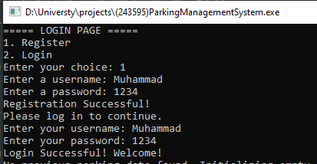

* The menu.

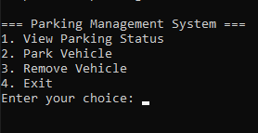

* Parking status display.

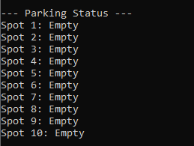

* Examples of parking and removing vehicles.

Park vehicle

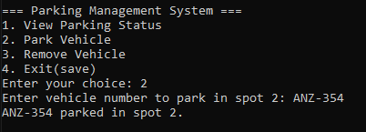

Remove vehicle

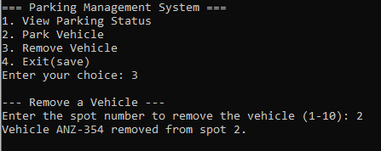

# **4. Results and Discussion**

## **Output:**

* Users can log in, park vehicles, remove vehicle, and check parking status.
* Files (users.txt and parkingData.txt) correctly store user and parking data.

**Discussion:**  
The system is simple and works well for managing parking spots. It uses basic C++ programming concepts and it is very easy to understand and use.

# **5. Conclusion and Future Work**

**Conclusion:**  
The system makes parking management easier by automating these tasks. It shows how to use C++ for practical applications.

## **Future Work:**

* Add a graphical interface for easier use.
* Allow more than 10 parking spots.
* Add different user roles, like admin and regular users.
* Improve security by encrypting user passwords.

# **6. References**

1. Starting out with C++ (Book by Tony Gaddis)
2. [File Handling in C++](https://www.geeksforgeeks.org/file-handling-cpp/)
3. [System Design Tips](https://en.cppreference.com/)